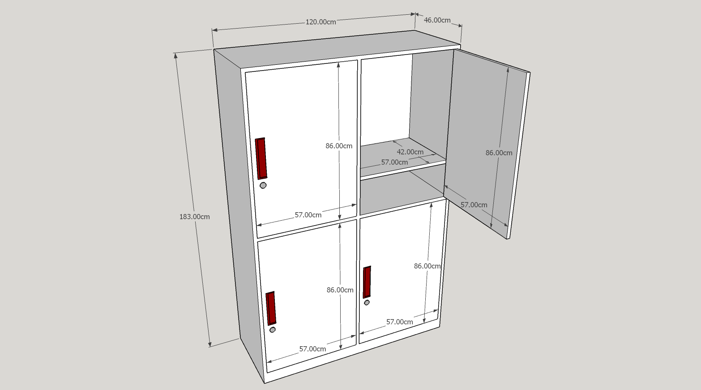
26 pcs –4 Doors Cabinet Locker (Customized)
Color: Beige and Black
Material: Wooden Type (Hard wood-good quality)

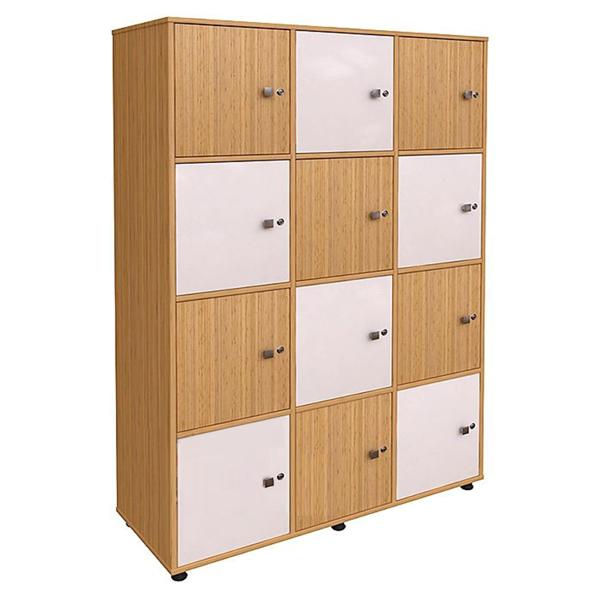
10 pcs -12 Doors Kitchen cabinet/locker (Customized)
Dimension: H-184.5 cm x L-91.5 cm x W-40 cm
Color: Beige and White
Material: Wooden Type (Hard wood-Good quality)
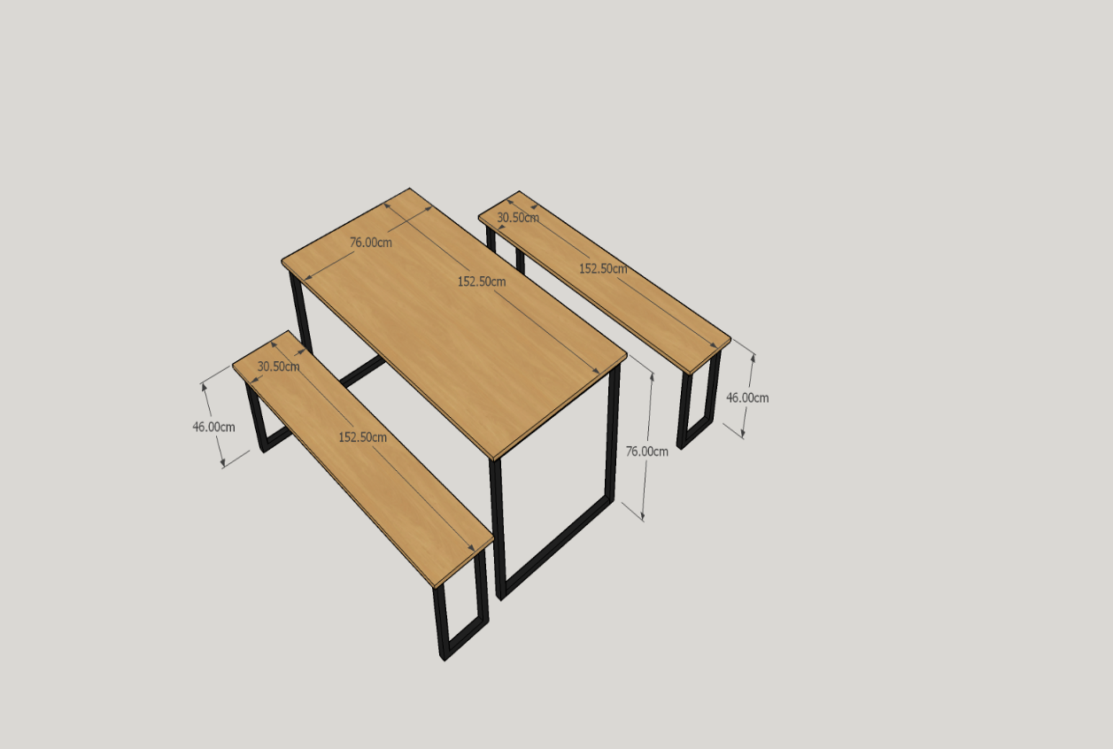

27 sets – 6 Seaters Dining Table (Customized)
Color: Black and Beige
Material: Wooden Type (Hard wood-good quality)
Wood frame: 4.5cm x 4.5cm

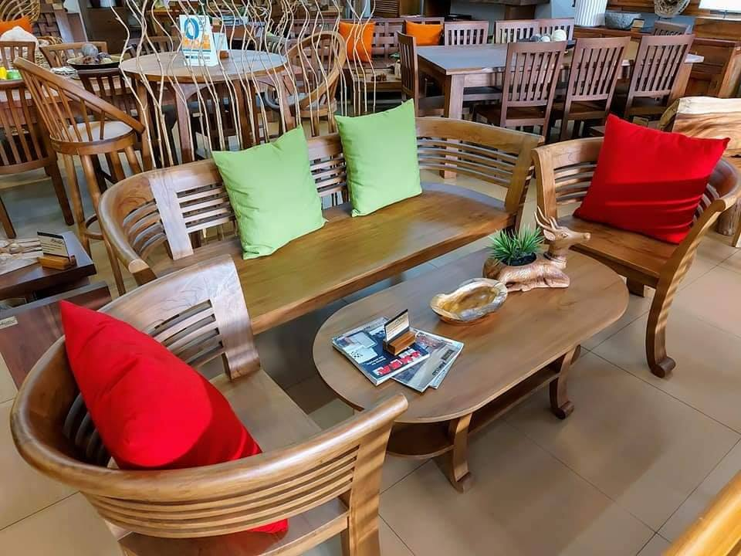
1 Set- Sala Set - Material: Wooden Type (Hardwood-good quality)
Color: Varnished
wooden sofa –standard: 3 seaters
2 single seaters
1 center table – width- 51cm. : length - 96cm. : height - 51cm

